Japan Wakes to Devastation: Death Toll Climbs, Rescue Effort Continues

By: Emily Rauhala
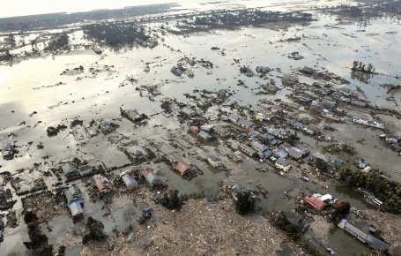
Reuters/Kyodo
Flooding following an earthquake and tsunami is seen in Sendai, northeastern Japan March 12, 2011.
Large sections of northeastern Japan are in a state of chaos this morning, as rescuers struggle to reach survivors of yesterday's earthquake and tsunami.
As TIME reported yesterday, a massive earthquake hit Japan Friday afternoon, setting off a tsunami that sent walls of water crashing into coastal cities. Since then, concerns have emerged about possible radiation leaks from nuclear plants.
The death toll is now expected to rise to at least 1000, though that figure has not been confirmed. NHK, Japan's national broadcaster now says 1,300 are dead or missing.
The government is warning people to stay away from the coast.
http://newsfeed.time.com/2011/03/11/japan-wakes-to-devastation-death-toll-climbs-rescue-effort-continues/

